FOUNDATION FOR VIRTUAL AND AUGMENTED REALITY SYSTEMS
Lecture54
Lec-54: VR resource optimization
Hello and welcome to the NPTEL MOOCs course on Foundation for Virtual and Augmented Reality Systems. We are going to start a new topic that is on VR Resource Optimization. So, if we quickly recollect what we have learned so far. So, we talked about the idea of optimization in the extended reality domain. So, what do we mean by it? And
major types of optimizations, that is experience optimization, psychophysiological optimization, and resource optimization. Now, earlier we talked about experience optimization in the context of VR or immersive experience, where we talked about techniques to reduce or minimize the onset of cyber sickness. Now, in this lecture, we are going to learn about ways to optimize the VR resource requirements. So, previously we learned about optimizing VR experience.
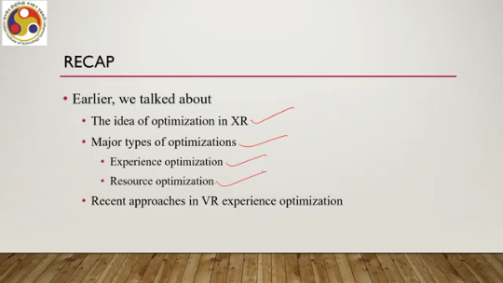
Now, we are going to talk about optimizing VR resource requirements. Now, in order to understand the optimization, we need to first understand the requirements. What are the resource requirements that we are talking about? So extended reality or XR, in particular VR or virtual reality, is resource hungry. That means they require a lot of resources.
So we should build systems to minimize the requirement of resources as well, along with trying to build systems that optimize the experience. Now, while trying to minimize resource requirements, we should also have to keep in mind that we need to maximize the experience. So both are our objectives: minimize resource requirements without compromising on experience, that is, maximize the experience. Now, the thing is that we wish to optimize resources. But when we use the term resources, what do we mean by it?
What do we mean by the term resource in the context of extended reality in general and virtual reality in particular? Now, resource in a very broad sense can mean any or all of the following things, namely hardware. We can talk of hardware resources. Software resources, these are quite obvious. Even manpower is a resource.
Supporting infrastructure such as physical infrastructure as well as digital infrastructure, physical infrastructure such as a room, furniture, digital infrastructure such as the network setup and so on. These are all can be considered as resources. Now, in the context of VR, we can say resource refers to the hardware part, that is, input devices, processing devices, output devices and so on.
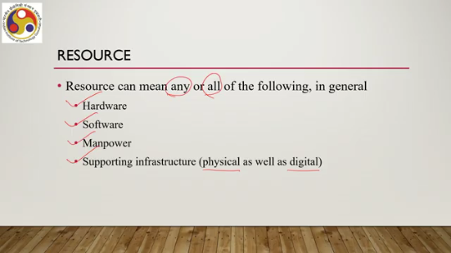
The software part includes developmental tools, software development kits, software packages or application packages, and so on. Manpower also, such as staff for development, deployment, maintenance, marketing, and so on. Supporting infrastructure, such as rooms to keep the setup, the hardware setup, supply of electricity, furniture, and so on. Or the infrastructure related to the network, network gears, switches, routers, wires, servers, and so on.
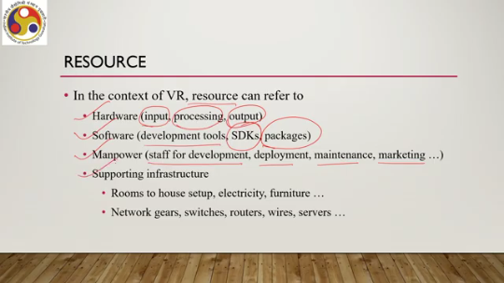
So, that is the digital infrastructure. So, all these can mean resources. Now, we can separately try to optimize each resource type; that is possible, but although it may be possible, it is not easy. It involves lots of considerations, and these considerations vary widely. Money can be one consideration: availability of funds, how to manage the resources; based on that, we can try to optimize the resources.
Availability, whether we can avail the resources before we use them. Even policy issues, whether some policy allows us to use the resources, and geopolitical issues may also play a role in the availability or affordability of the resources. So, all these can be considered for resource optimization, but then, as I said, it is not easy to consider everything. So, we generally do not try to optimize everything.
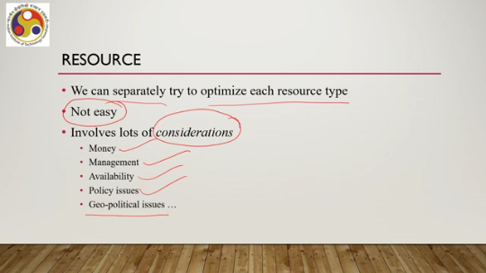
Some things are already given; that is our assumption. Based on that, a lesser number of resources we try to optimize. So instead, we focus on optimizing hardware requirements at the client end. That is the most straightforward way of optimizing resources rather than getting entangled in so many issues.
So, our focus is optimizing the hardware requirements at the client end. That is what the user has access to. More specifically, our objective is to allow the client, in this case the end user, to have a good experience with affordable hardware resources. So, we are only trying to optimize the hardware resources that are there at the client end or at the user end.
Now, in order to fully understand how to optimize that resource, that is the hardware at the client end, we need to know what hardware we need, for a good VR experience and why we need the hardware. So, this what and why are the crucial aspects of understanding the overall optimization approach. We have already gone through the what part in our earlier lectures; that is what hardware we typically use in VR. You may refer to that relevant lecture which we covered in an earlier part of the course.
Also, we briefly discussed the why part, that is, why we require that hardware. The simple answer is to support requirements arising from rendering or computer graphics. So, earlier we briefly mentioned that. The hardware that we typically employ for a good immersive experience is needed to manage the rendering or computer graphics related issues. So, here we will elaborate further on this why part, that is, why we need the hardware,
what computer graphics is, and what are the issues that propel us to use the particular hardware to address the computer graphics issues. In other words, why computer graphics requires special hardware in the context of VR. That is what we are going to discuss in this lecture. So, in order to understand why computer graphics requires special hardware, what we will do is discuss the basic idea of computer graphics, how images are rendered on a computer screen or any display.
It may be noted that here we will be restricting our discussion to very fundamental and basic concepts of computer graphics without going into the advanced details. And here we will be primarily focusing on understanding the rendering of static images on a screen, whereas in reality, particularly in VR or immersive experiences, we have dynamic scene change, which can be understood in terms of static things plus some other concepts which we are not going to cover here. However, the basic discussion will lay a foundation for understanding the complexity required to render a scene and, correspondingly, the need for high-end hardware support. So, let us try to understand briefly what computer graphics is.
In order to understand that, let us start with an example shown here on this screen. As you can see here, there is an object shown on an interface. An interface is what you get to see on a computer screen. So, this is nothing but an image displayed on the screen. It is constructed with objects.
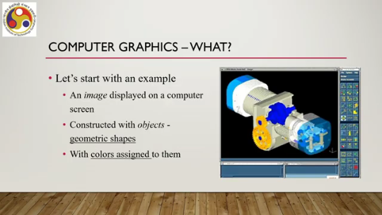
which are of geometric shapes. Now, here the term object means objects which are part of this particular item as well as objects that are part of the interface, say these menus, icons; all these are also objects. And we can also see that colors are assigned to these objects, the main object as well as the interface objects. So, we have an image.
The image is the whole thing, not only the main object. This whole thing is the image displayed on the screen. The image comprises geometric shapes, and there is color attached to each shape. Now the images or parts can be manipulated, typically which we call interaction. So, interacted with by a user using some sort of input devices, such as a joystick or other devices that we can associate with VR input.
So, when we interact with the object, the object's appearance changes. The screen changes. So, many things change. Now, we know that computers understand only binary language, that is, the language of zeros and ones, but images or components are definitely not strings of zeros and ones. So, when I see an image, it is not that I am seeing only strings of zeros and ones; I am seeing
something with which we are familiar in the real world. But computers do not understand that. Computers understand everything in the form of zeros and ones. So then the issue is, that is the fundamental question: how can we create or represent, synthesize, and render imagery on a computer display? There are two sides.
One is that computers understand only binary representation, whereas humans perceive realistic representation, not strings of zeros and ones. So, how can we do that? How can we create or represent objects, synthesize objects into a scene, and render it on a computer screen so that humans can perceive it? Now, this fundamental question gives rise to four basic questions. How to represent objects or parts of an image?
How to synthesize? So, one is representation; the second one is synthesis. How to synthesize parts to form complete realistic imagery? Then, how to allow users to manipulate images on screen? And finally, how to create the perception of motion?
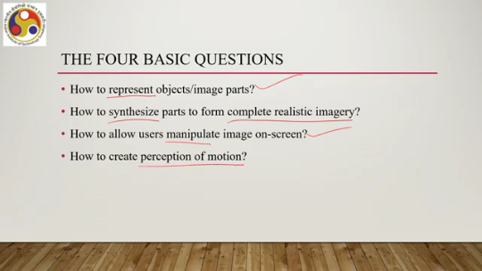
Now, among these things, this is related to interactive systems, and this is related to animation. So, here we will be focusing on these two parts. We will not be focusing on interactive graphic systems or computer animation. Those are more involved discussions and conceptually an extension of the basic understanding of how an image, a static image, is rendered. So, in order to understand how a static image is rendered, that means how the components are represented, how they are synthesized, and finally rendered on the screen.
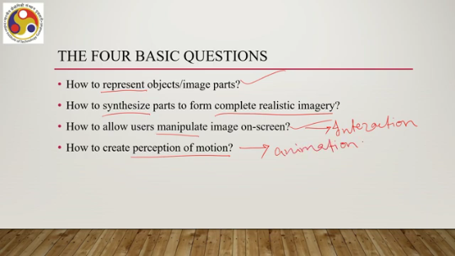
Let us first start our understanding with an understanding of the generic graphics system. When we say that we have a graphics system, what we mean, what are the major components, and also we will learn about a few basic terms in order to understand the process of rendering. So, this is what a generic graphics system may look like. We have a host computer, and we have the display. And in between, there are three major components: a display controller, video memory, and a video controller.
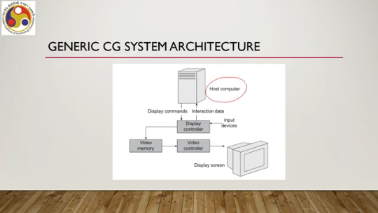
As you can see, the host computer or CPU sends display commands and may receive some interaction data. So, there is two-way communication between the display controller and the CPU. Now, the display controller sends some data to video memory for storage, and this data is utilized by the video controller to render an image on screen. There can be input devices using which the user is interacting with the scene. So, that is part of interactive graphics.
However, we will not pay much attention to the input part in this discussion to keep things simpler. Now, let us try to understand these three components: the display controller, video memory, and video controller. Let us start with the display controller. What is the idea? Image generation. So, when I say that I am rendering a scene on the screen, that is nothing but a 2D image displayed on a 2D screen.
Now, this image generation is a multi-stage process involving lots of computations. If all these computations are to be carried out by the CPU or the host computer, the CPU may get very little time for doing other computational tasks which are not related to rendering. Its time will be consumed by rendering-related computations. So, in such cases, the system cannot do much except rendering, which of course defeats the very purpose of having a computer.
To avoid such situations and increase the efficiency of the system, the process of rendering is usually carried out by a dedicated component of the system. That is popularly known as the graphics card. Typically, graphics cards come with their own processing unit called GPU or graphics processing unit. So, we have a dedicated component in a computer which deals with rendering-related computations that is typically called the graphics card, comprising a GPU or graphics processing unit. And that is what we are referring to as the display controller in a very generic way.
The CPU typically assigns any graphics rendering task to this separate graphics unit. which we are calling the display controller. So, if graphics-related tasks appear, the CPU simply passes them on to the display controller; the computation takes place in the GPU and necessary action is taken. So, the CPU does not get involved in the computation. So, that is the display controller, which is responsible for creating a representation of the image that can be rendered on the screen.
Then comes the second part. So, we talked about the display controller. Then we have video memory. Let us see what this is. Now, the display controller generates the image in a digital format: strings of zeros and ones.
Remember that a computer can only understand zeros and ones. And that is what the display controller outputs in the form of zeros and ones, a representation of the image. Now, the place where it is stored is called the video memory. which is a dedicated part of the overall memory hierarchy of the computer and is typically part of a separate graphics unit. Sometimes it is called the VRAM or video RAM in the graphics card.
So, modern graphics cards come with a memory component which is this video memory. So we have a display controller which generates the image representation in zeros and ones which gets stored in the video memory part, and then we have the video controller, the third component. Now, a display screen contains picture elements or pixels. Any graphic display screen generally comes with a grid of pixels. So, arranged in the form of a grid.
When these pixels are excited, now this term is a generic term, excited means activated. By some means, it can be electrical or electromechanical, etc. Those pixels start emitting some light with specific intensities, which gives us the sensation of a colored image on the screen. So, on the display screen we have a pixel grid that is activated to emit light which, when it reaches our eye, we perceive as a colored image on the screen. Now, the video controller, the unit that we are talking about, converts the digital image that is stored in the video memory to some analog voltages required to activate pixels.
or activate the pixel excitation mechanism. So, the video controller essentially controls the mechanism that activates the pixels, and this mechanism relies on the video memory content. That is a generic graphic system. Now, when we are talking about rendering, the rendering process can be thought of in two ways.
So, there are broadly two types of rendering. Accordingly, we can say there are broadly two types of graphic devices. Now, these types are determined based on the method used for excitation of pixels. How are the pixels excited? One is the vector scan device; the other one is the raster scan device.
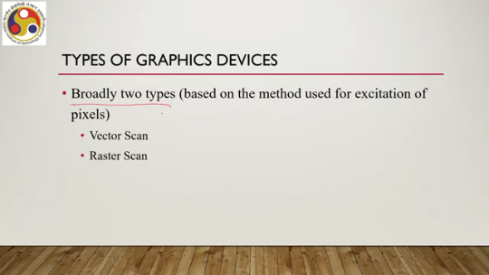
What happens in a vector scan device? Such devices are also known as random scan, stroke writing, or calligraphic devices. So, here, any image is viewed as composed of continuous geometric primitives, such as lines or curves. So, when we are presented with an image, we can think of it as containing basic geometric shapes, such as lines and curves. Then the image is rendered by rendering these primitives.
So, essentially the mechanism to render the image is to activate pixels that represent these primitives, assuming that if we focus on the rendering of the primitives, then the whole image will be perceived. So, essentially the idea is to excite only selective pixels in the pixel grid that represent the primitives. The idea is illustrated here.
As you can see, suppose we have a line. Now, I want to display this line. Now, this line contains these pixels, but this is the whole pixel grid. So, each cell contains one pixel. However, to display or render this line, what a vector scan device would typically do is to excite only those pixels that define the line.
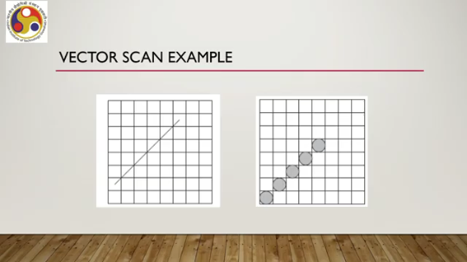
Other pixels will not be excited or activated. Clearly, it requires high precision, high precision to target the specific pixels and excite them, which makes the systems costly and typically unaffordable for mass production or mass consumption. So, these are used typically; these types of graphic devices are typically used in specialized settings where limited quantity is required to make graphic systems that are more affordable and correspondingly easily available commercially.
A separate type of rendering mechanism is used that is called raster scan devices. So, in a raster scan device, what happens is that the image is viewed as represented by the whole pixel grid, not only the selected pixels representing the primitives. All the pixels are considered for rendering. Not the selected pixels. So, correspondingly, we do not require that high precision to target and activate selected pixels.
So, this is achieved by considering pixels in sequence. Some sequence has to be maintained to activate all pixels with appropriate input so that all can emit light with appropriate intensity so that the overall perception comes. Now, typically, the sequence is from left to right, top to bottom. Now, this process of basically scanning or basically selecting all the pixels in sequence is called scanning or raster scanning. Let us see an example.
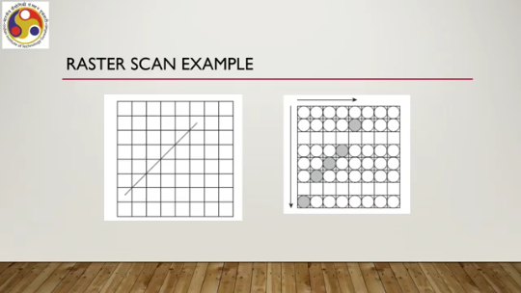
Similar to the previous one, we want to render this line. On this pixel grid. However, unlike in the previous case, here we will activate all pixels with this sequence: left to right and top to bottom. That means we will start activation from the top left pixel, then proceed to the next, next till the last pixel. Then we will come back to the first pixel in the next row, proceed next, next in that way to the last one.
Then come back to the first pixel in the next row, and so on, until we reach this bottom right pixel. So, this is the left-to-right, top-to-bottom scanning sequence. Here we are activating all pixels with different input so that they emit intensity with different, so that they emit light with different intensity, so that eventually we perceive that there is a line. Although all pixels are getting excited, we will be able to perceive the line because those pixels on the line will be excited in a different way as compared to the surrounding pixels.
So, here, since we are following a sequence and activating all pixels, we do not require precision. So, the corresponding rendering mechanism, rendering arrangement, is much, much cheaper as compared to the selective rendering required for vector scan devices. And all the commercial products that you get to use, such as your smartphone or television or any device with some sort of computer and display, typically comprise raster scan displays.
There is another term that we should know of, that is called the frame buffer. Earlier we talked of a video memory which stores the image in the form of zeros and ones. Now, when we are talking of the video memory for a raster scan system where we are storing the intensity values for all pixels in the grid, the more generally accepted or popular term is called the frame buffer. So, the frame buffer essentially is the video memory component of the raster scan system.
It contains one location corresponding to each pixel. So, for each pixel there is one memory location which stores the intensity in the form of a bit string of 0s and 1s. So, the size of the frame buffer is the size of the screen, or in other words, the size of the frame buffer is equal to the screen resolution. So, the frame buffer is the video memory for raster scan devices, and its size is exactly the same as the screen resolution.
Another important concept here is screen refreshing. Light emitted from pixel elements after excitation starts decaying over time. That is the physical property of the material which makes the pixels. Now, this decaying light leads to fading of the scene after some time. Although the image is not changing, the scene starts fading because the emitted light starts decaying over time.
Pixels in a scene may get excited at different points in time and hence may not fade in sync, which may lead to image distortion. So, when we are rendering on a raster scan device, we are following a left-to-right, top-to-bottom manner. So, excitation of the top-left pixel is done much ahead of the excitation of the bottom-right-most pixel. By the time the bottom-right-most pixel is excited, the top-left pixel may start decaying, and this may happen with other pixels as well.
So, correspondingly, the image that we finally get to see may not appear uniform and may appear distorted. That is another issue with this decaying. One is the scene starts fading; the second one is the scene may not be rendered without distortion. To avoid this, what is typically done is to keep on exciting the pixels periodically. This is called refreshing.
So, although the image is not changing, the scanning mechanism still happens periodically so that we get to see uniformity in the image rendered. The refresh rate is the number of times a scene is refreshed per second on the screen. It is typically represented in terms of hertz, and a good refresh rate for most devices is 60 hertz. However, as we noted earlier in one of our discussions on human factors, a higher refresh rate is always preferable for virtual reality because here the screen is much closer to the eyes as compared to typical computer usage where the screen and eye are
reasonably at a distance. So, a higher refresh rate is always preferable for a VR experience, a better VR experience. Also, let us quickly understand what we are referring to when we talk of a color image. So, pixels are materials. When we are talking of color screens or color displays, we are talking of a specific thing: that each pixel contains more than one type of element.
And each type of element is capable of emitting light with different intensities than the other type of element. So, when excited, the three elements, typically three elements are there. although sometimes four can be used for different purposes. However, let us assume that there are three elements for each pixel. These three elements can emit light with three different intensities which typically represent the primary colors, that is, red, green, and blue.
Now, when we get to see these emissions when they come to our eye, Essentially, what happens is that this red, green, and blue get mixed up in our eye, and due to this mixing, we get to see a different color, which is a combination of different amounts of red, green, and blue. So, that is how we perceive color. However, more on it we will discuss in a later part of the lecture.
So, let us summarize what we have discussed so far. We started our discussion on resource optimization concepts in XR and, in particular, in VR. We talked of different resources and the need for optimizing those resources. However, we emphasized that optimizing all resources may not be feasible or practical. So, we are focusing on optimizing hardware resources at the client end.
Now, in order to do that, we first need to understand the what and why of the hardware resources: what is the hardware resource, and why we need to go for high-quality hardware resources. The what part we have already discussed earlier when we talked about VR hardware; the why part we also briefly touched upon. However, to better understand the why part, we need to understand how rendering takes place, which leads us to the understanding of computer graphics. So, here we started our discussion on computer graphics. We started with explaining a few basic terms and a generic architecture.
In the subsequent part of the lecture, we will be covering a concept known as the 3D computer graphics pipeline, or 3D graphics pipeline in short, which refers to the process of computation starting from object representation to rendering on the pixel grid. This is a stage-wise process, and the stages together are called the 3D graphics pipeline. We are going to talk about that pipeline in subsequent parts of the lecture. So, I hope you could follow the discussion, you could follow the concepts and topics that were discussed.
Looking forward to meeting you all again in the next part of the lecture. Until then, thank you, goodbye, and happy learning.

